ONLINE EXAM SYSTEM
A MINI-PROJECT REPORT
Submitted by

AJAY PRASATH P 240701023
ASWIN SIDDHARTH A 240701064
ASHVANTHAN SR 240701056

in partial fulfillment of the award of the degree
of
BACHELOR OF ENGINEERING
IN
COMPUTER SCIENCE AND ENGINEERING

RAJALAKSHMI ENGINEERING COLLEGE, CHENNAI
An Autonomous Institute
CHENNAI
NOVEMBER 2025

BONAFIDE CERTIFICATE
Certified that this project “Customer Churn Prediction” is the Bonafide work of “AJAY PRASATH P, ASWIN SIDDHARTH A, ASHVANTHAN SR” who carried out the project work under my supervision.

SIGNATURE
Dr. AKSHAIKHAANTH
PROFESSOR
Dept. of Computer Science and Engg,
Rajalakshmi Engineering College
Chennai

This mini project report is submitted for the viva voce examination to be held on __________

INTERNAL EXAMINER EXTERNAL EXAMINER
ABSTRACT

Customer retention is a key challenge for telecommunication companies, as predicting potential customer churn can significantly reduce revenue loss. This project focuses on building a predictive model using data science techniques to identify customers likely to discontinue their services. The dataset used is the Telco Customer Churn dataset, which includes various demographic, account, and service-related features. The data was cleaned, encoded using one-hot encoding, and split into training and testing sets. Multiple machine learning algorithms—Logistic Regression, Decision Tree, and Random Forest—were implemented and compared based on their accuracy scores. A Voting Classifier was then applied to combine these models for better performance. Among the models, Logistic Regression achieved the highest accuracy of approximately 79.5%, followed by Random Forest and Decision Tree. The final ensemble model achieved an accuracy of 77.8%, demonstrating reliable churn prediction capability. This project highlights the effectiveness of ensemble learning in improving classification performance and provides a foundation for proactive customer retention strategies.

ACKNOWLEDGEMENT

We express our sincere thanks to our beloved and honorable chairman MR. S. MEGANATHAN and the chairperson DR. M.THANGAM MEGANATHAN for their timely support and encouragement.
We are greatly indebted to our respected and honorable principal
Dr. S.N. MURUGESAN for his able support and guidance.
No words of gratitude will suffice for the unquestioning support extended to us by our Head of The Department Dr. E.M. MALATHY and our PROFESSOR Dr. AKSHAIKHAANTH for being ever supporting force during our project work
We also extend our sincere and hearty thanks to our internal guide Dr. AKSHAIKHAANTH, for her valuable guidance and motivation during the completion of this project.
Our sincere thanks to our family members, friends and other staff members of computer science engineering.
1. AJAY PRASATH P
2.ASWIN SIDDHARTH A
3. ASHVANTHAN SR

TABLE OF CONTENTS

CHAPTER NO. TITLE PAGE NO
ABSTRACT iv

1 INTRODUCTION 1
1.1 INTRODUCTION 1
1.2 SCOPE OF THE WORK 1
1.3 PROBLEM STATEMENT 1
1.4 AIM AND OBJECTIVES OF THE PROJECT 1
2 SYSTEM SPECIFICATIONS 2
2.1 HARDWARE SPECIFICATIONS 2
2.2 SOFTWARE SPECIFICATIONS 2
3 MODULE DESCRIPTION 3
4 CODING 4
5 SCREENSHOTS 8
6 CONCLUSION AND FUTURE ENHANCEMENT 10
7 REFERENCES 11

LIST of figures
FIGURE NO. | TITLE | PAGE NO.
5.1 | Sample Dataset | 8
5.2 | Model Prediction Score | 8
5.3 | Model Accuracy Heat Map | 9

CHAPTER 1
INTRODUCTION
  - INTRODUCTION
The Customer Churn Prediction System uses machine learning to predict whether a customer will discontinue a service. It analyzes factors such as demographics, account details, and service usage to identify patterns leading to churn. This helps companies take preventive actions to retain customers and improve satisfaction.

1.2 SCOPE OF THE WORK
This project focuses on developing a predictive model using the Telco Customer Churn dataset. It involves data preprocessing, applying algorithms like Logistic Regression, Decision Tree, and Random Forest, and improving accuracy with a Voting Classifier. The system can be integrated into business tools to support customer retention strategies.
1.3 PROBLEM STATEMENT
Customer churn causes major revenue loss in telecom industries. Traditional methods fail to accurately detect potential churners due to complex data patterns. Hence, a machine learning–based approach is needed to predict customer churn effectively and help businesses retain valuable customers.
1.4 AIM AND OBJECTIVES OF THE PROJECT
The aim of this project is to build a machine learning model that accurately predicts customer churn. It focuses on analysing customer data to identify key churn factors and applying predictive algorithms to help businesses recognize and retain customers likely to leave.

CHAPTER 2
SYSTEM SPECIFICATIONS
2.1 HARDWARE SPECIFICATIONS
The project requires a computer system with basic to moderate processing capabilities. A system with an Intel i3 processor or above, 8 GB RAM, and at least 500 GB of storage is recommended. A stable internet connection is also required for downloading libraries, datasets, and dependencies.
2.2 SOFTWARE SPECIFICATIONS
The project is developed using Python with libraries such as pandas, NumPy, matplotlib, seaborn, and scikit-learn. The development environment used is Jupyter Notebook or Anaconda Navigator. The system runs on Windows 10 or above (or any compatible operating system with Python support).

CHAPTER 3
MODULE DESCRIPTION
The Customer Churn Prediction System is divided into several modules that work together to analyze customer data and predict churn effectively.
1.Data Collection and Preprocessing:
This module involves importing the Telco Customer Churn dataset, handling missing values, removing duplicates, and encoding categorical data to prepare it for analysis.
2. Exploratory Data Analysis (EDA):
In this module, various visualizations are created using matplotlib and seaborn to understand relationships between features and identify important factors influencing churn.
3. Model Building:
This module focuses on applying machine learning algorithms such as Logistic Regression, Decision Tree, and Random Forest to train predictive models using the processed dataset.
4. Model Evaluation:
Each model’s performance is tested using accuracy scores and confusion matrices. A Voting Classifier is also implemented to combine models for improved prediction accuracy.
5. Prediction Module:
This final module allows new or unseen customer data to be inputted into the trained model, which then predicts whether the customer is likely to churn or not.
CHAPTER 4
CODE
import pandas as pd
import numpy as np
import matplotlib.pyplot as plt
import seaborn as sns
from sklearn.model_selection import train_test_split
from sklearn.linear_model import LogisticRegression
from sklearn import tree
from sklearn.ensemble import RandomForestClassifier, VotingClassifier
from sklearn.metrics import accuracy_score, confusion_matrix

df = pd.read_csv('Telco-Customer-Churn.csv')
df.dropna(inplace=True)
df.drop_duplicates(inplace=True)

target = df['Churn']
df = df.drop(['customerID', 'Churn'], axis=1)
target = target.replace({'Yes': 1, 'No': 0})
df = pd.get_dummies(df, drop_first=True)

x_train, x_test, y_train, y_test = train_test_split(df, target, test_size=0.5, random_state=42)

model1 = LogisticRegression(max_iter=1000)
model2 = tree.DecisionTreeClassifier(random_state=42)
model3 = RandomForestClassifier(n_estimators=80, random_state=42)

model1.fit(x_train, y_train)
model2.fit(x_train, y_train)
model3.fit(x_train, y_train)

print("Logistic Regression Accuracy:", model1.score(x_test, y_test))
print("Decision Tree Accuracy:", model2.score(x_test, y_test))
print("Random Forest Accuracy:", model3.score(x_test, y_test))

models = [('logreg', model1), ('dtree', model2), ('rforest', model3)]
ensemble = VotingClassifier(estimators=models, voting='soft', n_jobs=-1)
ensemble.fit(x_train, y_train)

print("Voting Classifier Accuracy:", ensemble.score(x_test, y_test))

y_pred = ensemble.predict(x_test)
cm = confusion_matrix(y_test, y_pred)

sns.heatmap(cm, annot=True, fmt='d', cmap='Blues')
plt.title('Confusion Matrix')
plt.xlabel('Predicted')
plt.ylabel('Actual')
plt.show()

sample_input = pd.DataFrame([x_test.iloc[0]], columns=x_train.columns)
prediction = ensemble.predict(sample_input)
print("Predicted Churn:", "Yes" if prediction[0] == 1 else "No")

CHAPTER 5
SCREEN SHOTS
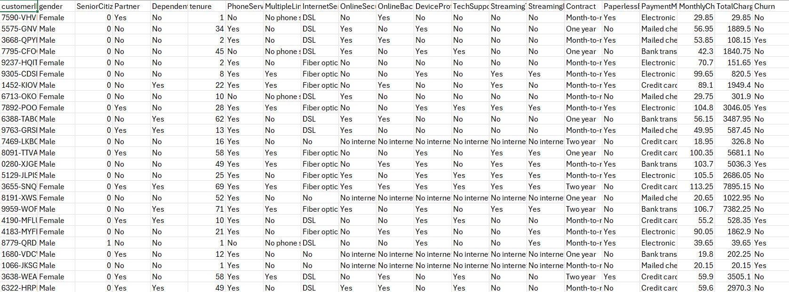
5.1 - Sample Dataset
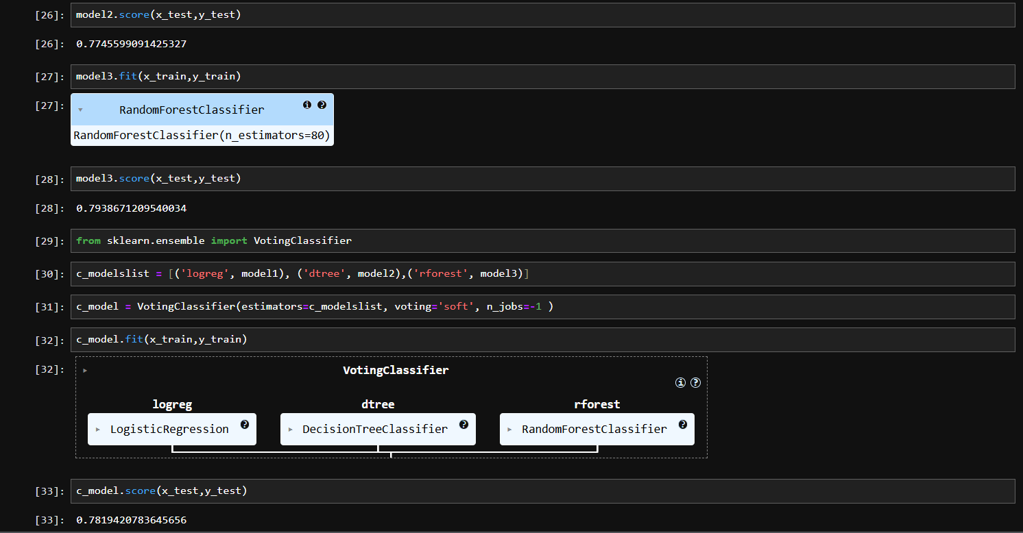
5.2 - Model Prediction Score
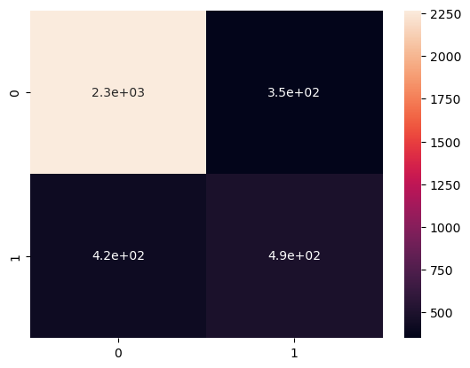
5.3 - Model Accuracy Heat Map

CHAPTER 6
CONCLUSION AND FUTURE ENHANCEMENT
The Customer Churn Prediction System successfully applies machine learning techniques to analyze customer data and predict churn with reliable accuracy. By implementing models such as Logistic Regression, Decision Tree, and Random Forest, and combining them using a Voting Classifier, the project demonstrates how data-driven approaches can help businesses identify customers likely to leave and take preventive actions to retain them. This predictive system provides valuable insights that can enhance customer satisfaction and reduce business losses.
In the future, the system can be enhanced by integrating deep learning models and advanced feature selection methods to improve accuracy. A web-based or dashboard interface can also be developed for real-time predictions and visualization. Additionally, incorporating larger and more diverse datasets from multiple sources would make the model more robust and adaptable to various industries beyond telecommunications.

REFERENCES
- https://www.kaggle.com/blastchar/telco-customer-churn
- https://scikit-learn.org/
- https://pandas.pydata.org/
- https://numpy.org/
- https://matplotlib.org/
- https://seaborn.pydata.org/

